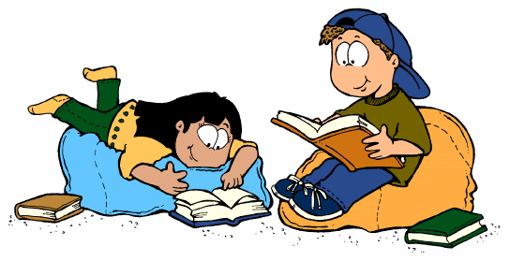
Complete the boxes to earn prizes! The more boxes you complete, the more prizes you earn! In order to qualify for the end of the year Readers’ Mystery Trip, you must complete 15 points worth of activities on each month’s Literacy Bingo boards (September 2015-April 2016). This month’s Bingo board is due back to Ms. Proctor by Wednesday, October 7th, 2015.

1 point  Bring your dot back for International Dot Day! | 1 point  Define ‘respect’ for Mrs. Thornton. | 1 point  Celebrate National Library Card Sign-up Month by showing Ms. Proctor your public library card. | 1 point  Tell me, in a few sentences, about something you have read recently that you found interesting – attach. | 1 point  Pick out 2 non-fiction text features in a story that you read – attach.
2 points  Turn your first name into an acrostic poem – attach. | 2 points  Create a circle map prior to reading a book to make predictions about what might happen in the book – attach. | 2 points  List, define, and use in a sentence a word that you came across while reading – attach. | 2 points  Read a book an adult has suggested to you.  Title: __________  Suggested by: _______________  Initials: ________ | 2 points  Create a comic strip story that shows what could happen if you do not practice safety when on the Internet – attach.
3 points  Write a paragraph explaining some of the ways you can stay safe when on the Internet – attach. | 3 points  Celebrate Hispanic Heritage Month by reading a short story or book featuring main characters who are Hispanic. | 3 points  Write a paragraph telling about your favorite author. Make sure to include your information sources – attach. | 3 points  Read a current or former Battle of the Books book and fill out any Thinking Map (with a reference frame) for it – attach. | 3 points  Read any book and do any Thinking Map (with a reference frame) – attach.
4 points  Read Dogo News’ article about book vending machines. Find it online or see Ms. Proctor for a copy. Answer the article’s questions – attach. | 4 points  Does reading a recipe count as reading? Write a paragraph or more defending your answer – attach. | 4 points  Make school rules cool by turning them into a poem, song or rap –attach. | 4 points  Celebrate Banned Books Week by reading a book from its list. Write a paragraph explaining why you think it may have been banned – attach. | 4 points  Write a letter to the author of a book you have read telling him or her how you feel about this book. Ask the author at least 3 questions about the book – attach.
5 points  Read any fiction or nonfiction book, complete any Thinking Map and recreate your favorite scene as a diorama – turn into Ms. Proctor. | 5 points  Read a biography and then create an interview between yourself and this person. What do you ask? How does he/she answer? – Attach. | 5 points  Read 2 books by the same author and use a Double Bubble Thinking Map to compare the two stories (include a frame of reference) – attach. | 5 points  Read any historical fiction book and use a Multi-Flow Thinking Map to show the cause and effect relationships of the main historical event in the book – attach. | 5 points  Read a fiction book and write a new ending for it. How do you think the book could have ended instead? – Attach.

