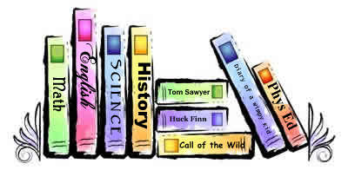
Dear Parents:

Welcome to a brand new year at Lee Woodard Elementary School!! I am very excited to have your child/children in my library and computer classes, and I cannot wait to get to know each and every one of them better as the year goes on! Next week your child will begin bringing home books that he/she has checked out from our Media Center.

You can greatly help your child by:

- Reading a book aloud together and letting your child tell you about the pictures.
- Helping him/her find a safe place to keep their book(s) so that it won’t get lost or damaged.
- Reminding your child to have clean hands when reading the book and to turn the pages with care.
- Encouraging your child to remember their library book on their library class days.
- Incorporating reading and literacy into your family time.
- Helping and encouraging your child to complete the monthly reading and literacy challenges we have for the students throughout the year (information will be coming about these next week).

Just like you, I want your child to succeed in school and to develop a love of reading and learning that will continue throughout his/her lifetime. Thank you for all that you do!

Sincerely,

Megan Proctor
School Media Coordinator
Lee Woodard Elementary School

