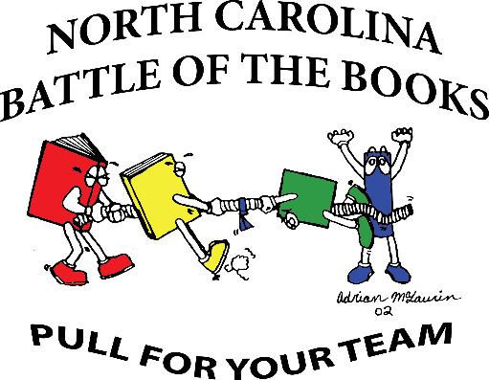
Dear LWES Parent(s),
Your child has expressed an interest in being on the Battle of the Books team for the 2015-2016 school year. As I have already discussed with him/her, being on the BOB team is a huge time commitment and involves a lot of extra effort beyond what the school day already requires. Currently I have between 35-40 students that want to participate. Unfortunately, state rules mandate that a Battle of the Books team have no more than 12 students for competition. Consequently, the 12 students that remain on the team will be those that have read the most books, completed all of the required assignments, have come to the team practices, and that behave in a manner that is respectful and team-oriented. At the bottom of this sheet is a pledge that you and your child should sign expressing his/her continued interest in trying out for the Battle of the Books team. By signing the pledge, students are agreeing to be responsible for all work, meetings, and their behavior. Once signed, please have your child return the pledge to me in the Media Center. Thank you for your time and ongoing support in your child’s education.
Sincerely,

Megan Proctor
---------------------------------------------------------------------------------------------------------------------------------------
As a part of Lee Woodard Elementary School's Battle of the Books team I, ______________________, pledge to:

- Read all 10 of my assigned books (out of 18 total). Though 10 is the expected number, I understand that more reading may be required to stay on the team.
- Attend all of the team meetings, unless otherwise discussed with Ms. Proctor.
- Meet all book deadlines and turn in all assigned work for each book including:
- A graphic organizer that records the book’s main characters, setting, a summary of the book, and its title/author (an example is attached).
- 10 questions about the book that can be used in team practice. These questions must follow the format outlined by the NCSLMA Elementary School Battle of the Books Manual (this format is attached and examples are included).
- Be respectful, responsible, and work as a team player.

I understand that the inability to follow through on any of the aforementioned responsibilities will result in my dismissal from the team.

___________________________________________________ (student’s signature)

___________________________________________________ (parent’s signature)
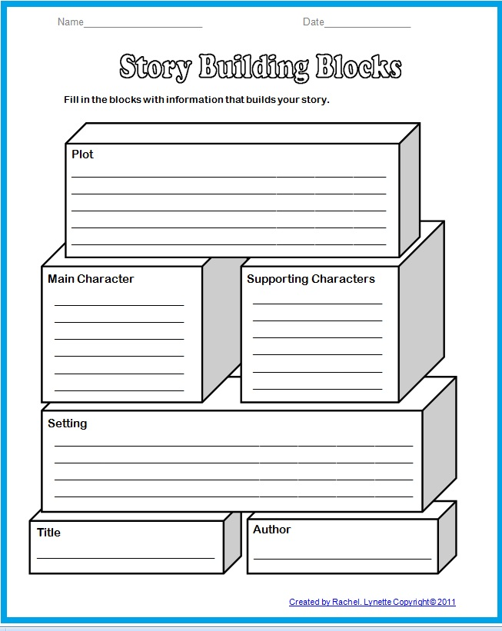
Guidelines for Writing EBOB Questions

1. Begin each question with "In which book…”
2. Use present tense, if possible, and correct grammar.
3. Character names and names of major setting locations cannot be used. Proper
names of places remote to a setting can be used. Example, if the main character
lives in Georgia but has always wanted to visit Italy, the question could read: "In
which book does a character save money to visit Italy?”
4. The pronouns “he”, “she”, “his”, or “her” may be used in writing questions.
5. Type the title and author as they appear on the official booklist.
6. Type the page number for the answer.
7. Avoid using words from the title.
8. Refrain from obvious questions.
9. Avoid questions that can be answered by more than one title.
10. Review each question to ensure all the criteria have been met (Are questions clear, concise, and correct)?
11. Do not use information written by people other than the author. Epilogues, prologues, and notes written by the author will be used to write questions.
Example Questions
- In which book does a character “eat like a lion?”
- In which book does a character hear the familiar sound “snick” as a door is being locked?
- In which book does a character state, “Being a mother is like trying to hold a wolf by the ears”?
- In which book is an alarm set off just for fun?
- In which book is a character’s soul set afire because of a lit match?

EBOB Due Dates Timeline

Book 1: Friday, October 2, 2015
Book 2: Friday, October 16, 2015
Book 3: Friday, October 30, 2015
Book 4: Monday, November 9, 2015
Book 5: Monday, November 16, 2015
Book 6: Monday, November 30, 2015
Book 7: Monday, December 7, 2015
Book 8: Thursday, December 17, 2015
Book 9: Friday, January 8, 2016
Book 10: Friday, January 22, 2016
EBOB Competition: Thursday, March 17, 2015

